The dataset used for this analysis consists of 1106 participants. Out of all 3600 unique CAPTAIN participants, 1188 participants had all non-NA values of ICS Setting total, the amount of ASD experience, and EBP primary outcome score. Then, from those 1188 participants, we excluded 82 participants (6.9%), whose SELPA and/or district were missing; 82 participants were missing districts and 60 of those 82 were also missing SELPA’s. SELPAs/districts are missing possibly because those participants are not part of specific SELPAs and/or districts. However, there is also possibility that the data is purely missing.

Out of the 1106 participants, 905 (81.8%) identified themselves as females and 128 (11.6%) identified themselves as males. The participants were from 111 different SELPAs and 305 different districts. Each SELPA and district contain 1 to 53 participants. Almost all of them are Direct Support Professionals (99.5%). 71.2% identified themselves as Caucasians, followed by 4.3% as Asians and 1.3% as African American, with 18.1% from mixed/other/refused categories. About half of them are younger than the age of 45 (52.8%).

The variables of the model we used in this report are Implementation Climate Scale (setting) total score, ASD experience, and Evidence Based Practice primary outcome. The range of ICS total is 0 to 100, with an overall mean of 38.1, and as for EBP outcome, the range is 0 to 4 with the mean 2.54. ASD experience was initially categorical, with values ranging from “Little to no experience” to “Extensive hands-on experience”, but we changed it into a 0-3 numeric scale. Although it was originally a categorical variable, we decided to quantify it and turn it into a continuous variable. Possible counter arguments may arise such as “People’s standards on the words such as, ‘Extensive’, ‘Moderate’, and ‘Some’, can be very subjective, so it would be a problem if we use the variable as an objective (numerical) measure.” Further discussions and verifications might be necessary.

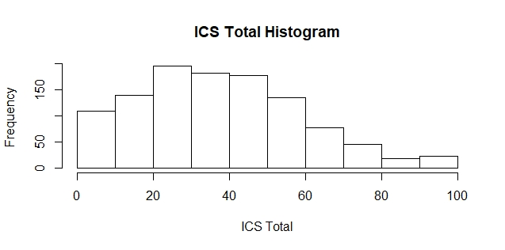Below are the histograms of the variables we used for the model in this report:

In our statistical model, we wanted to investigate the relationship between ICS total score and EBP outcome with the amount of ASD experience as a moderator. Multilevel modeling was conducted in R using lme4 package (Bates, Maechler, Bolker, & Walker, 2015). We first set up the unconditional model, where there isn’t any main nor interaction effects. We used SELPA and District as random effects. Therefore, below is the model:

*Model 1: EBP outcome ~ 1 + (1|District) + (1|SELPA)*

Then, using this base model, we added the variable, ICS total score, to see the main effect if it, so the model becomes:

*Model 2: EBP outcome ~ 1 + ICS Total + (1|District) + (1|SELPA)*

Testing between those two models above, we found that the main effect of ICS total score on EBP outcome was significant (Chi-square = 59.92, df = 1, p-value < 0.001). This result, along with the fixed effect estimate of ICS total greater than 0, indicates that the higher ICS total score, the higher EBP outcome score, and the relationship is significant.

Then, from the model 2, we added ASD experience variable as another main effect, so the model turns out:

*Model 3: EBP outcome ~ 1 + ICS Total + ASD Exp + (1|District) + (1|SELPA)*

Again, comparing the model 2 and 3 turned out to be significant (Chi-square = 108.75, df = 1, p-value < 0.001). This result, along with the fixed effect estimate of ICS total greater than 0, indicates that the higher ICS total score, the higher EBP outcome score, and the relationship is significant.

After investigating the main effects, we wanted to observe interaction effect, which will show how the two variables, ICS total and ASD experience, would relate to each other within the model. The model we fitted is shown below:

*Model 4: EBP outcome ~ 1 + ICS Total + ASD Exp + ICS Total \* ASD Exp + (1|District) + (1|SELPA)*

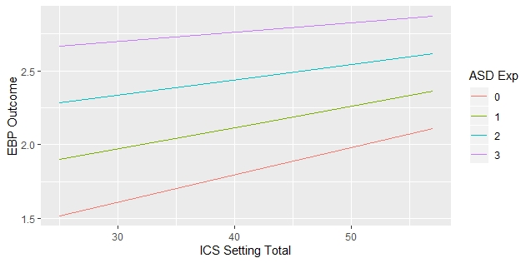Comparing model 3 and 4, we found that the interaction effect between ICS total and ASD experience was significant (Chi-square = 7.46, df = 1, p-value < 0.01). This result, along with the fixed effect estimate of the interaction less than 0, indicates that ASD experience is moderating the effect of ICS total on EBP outcome score. Below plot will explain this phenomenon visually:

As we can see in the plot, the slope of the lines decrease as ASD experience increases, and this is the sign of moderation (interaction) effect going on.